## 1.4 Inverse Functions

### Learning Objectives

* 1.4.1. Determine the conditions for when a function has an inverse.
* 1.4.2. Use the horizontal line test to recognize when a function is one-to-one.
* 1.4.3. Find the inverse of a given function.
* 1.4.4. Draw the graph of an inverse function.
* 1.4.5. Evaluate inverse trigonometric functions.

An inverse function reverses the operation done by a particular function. In other words, whatever a function does, the inverse function undoes it. In this section, we define an inverse function formally and state the necessary conditions for an inverse function to exist. We examine how to find an inverse function and study the relationship between the graph of a function and the graph of its inverse. Then we apply these ideas to define and discuss properties of the inverse trigonometric functions.

### Existence of an Inverse Function

We begin with an example. Given a function and an output we are often interested in finding what value or values were mapped to by For example, consider the function Since any output we can solve this equation for to find that the input is This equation defines as a function of Denoting this function as and writing we see that for any in the domain of Thus, this new function, “undid” what the original function did. A function with this property is called the inverse function of the original function.

|  |
| --- |
| NOTE |
| Definition Given a function with domain and range its inverse function (if it exists) is the function with domain and range such that if In other words, for a function and its inverse  1.11 |

Note that is read as “f inverse.” Here, the is not used as an exponent and [Figure 1.37](https://cnx.org/contents/8b89d172-2927-466f-8661-01abc7ccdba4@7.4:21bf0e2b-d95b-4e26-b9b9-fb7179ceaed1@8.html#CNX_Calc_Figure_01_04_001) shows the relationship between the domain and range of *f* and the domain and range of

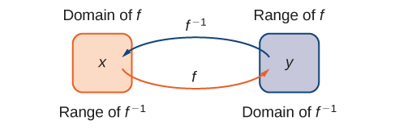

Figure 1.37 Given a function and its inverse if and only if The range of becomes the domain of and the domain of becomes the range of

Recall that a function has exactly one output for each input. Therefore, to define an inverse function, we need to map each input to exactly one output. For example, let’s try to find the inverse function for Solving the equation for we arrive at the equation This equation does not describe as a function of because there are two solutions to this equation for every The problem with trying to find an inverse function for is that two inputs are sent to the same output for each output The function discussed earlier did not have this problem. For that function, each input was sent to a different output. A function that sends each input to a *different* output is called a one-to-one function.

|  |
| --- |
| NOTE |
| Definition We say a is a one-to-one function if when |

One way to determine whether a function is one-to-one is by looking at its graph. If a function is one-to-one, then no two inputs can be sent to the same output. Therefore, if we draw a horizontal line anywhere in the -plane, according to the horizontal line test, it cannot intersect the graph more than once. We note that the horizontal line test is different from the vertical line test. The vertical line test determines whether a graph is the graph of a function. The horizontal line test determines whether a function is one-to-one ([Figure 1.38](https://cnx.org/contents/8b89d172-2927-466f-8661-01abc7ccdba4@7.4:21bf0e2b-d95b-4e26-b9b9-fb7179ceaed1@8.html#CNX_Calc_Figure_01_04_002)).

|  |
| --- |
| NOTE |
| Rule: Horizontal Line Test A function is one-to-one if and only if every horizontal line intersects the graph of no more than once. |

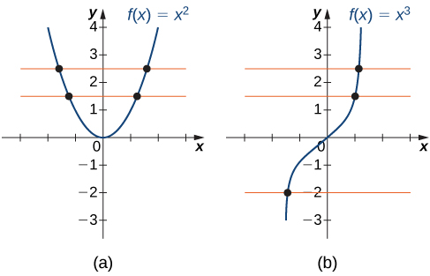

Figure 1.38 (a) The function is not one-to-one because it fails the horizontal line test. (b) The function is one-to-one because it passes the horizontal line test.

|  |
| --- |
| EXAMPLE |
| Example 1.28  |  | | --- | | EXERCISE | | Determining Whether a Function Is One-to-One For each of the following functions, use the horizontal line test to determine whether it is one-to-one.   1. An image of a graph. The x axis runs from -3 to 11 and the y axis runs from -3 to 11. The graph is of a step function which contains 10 horizontal steps. Each steps starts with a closed circle and ends with an open circle. The first step starts at the origin and ends at the point (1, 0). The second step starts at the point (1, 1) and ends at the point (1, 2). Each of the following 8 steps starts 1 unit higher in the y direction than where the previous step ended. The tenth and final step starts at the point (9, 9) and ends at the point (10, 9) 2. An image of a graph. The x axis runs from -3 to 6 and the y axis runs from -3 to 6. The graph is of the function “f(x) = (1/x)”, a curved decreasing function. The graph of the function starts right below the x axis in the 4th quadrant and begins to decreases until it comes close to the y axis. The graph keeps decreasing as it gets closer and closer to the y axis, but never touches it due to the vertical asymptote. In the first quadrant, the graph of the function starts close to the y axis and keeps decreasing until it gets close to the x axis. As the function continues to decreases it gets closer and closer to the x axis without touching it, where there is a horizontal asymptote.  Solution  1. Since the horizontal line for any integer intersects the graph more than once, this function is not one-to-one.   An image of a graph. The x axis runs from -3 to 11 and the y axis runs from -3 to 11. The graph is of a step function which contains 10 horizontal steps. Each steps starts with a closed circle and ends with an open circle. The first step starts at the origin and ends at the point (1, 0). The second step starts at the point (1, 1) and ends at the point (1, 2). Each of the following 8 steps starts 1 unit higher in the y direction than where the previous step ended. The tenth and final step starts at the point (9, 9) and ends at the point (10, 9). There are also two horizontal orange lines plotted on the graph, each of which run through an entire step of the function. 2. Since every horizontal line intersects the graph once (at most), this function is one-to-one.   An image of a graph. The x axis runs from -3 to 6 and the y axis runs from -3 to 6. The graph is of the function “f(x) = (1/x)”, a curved decreasing function. The graph of the function starts right below the x axis in the 4th quadrant and begins to decreases until it comes close to the y axis. The graph keeps decreasing as it gets closer and closer to the y axis, but never touches it due to the vertical asymptote. In the first quadrant, the graph of the function starts close to the y axis and keeps decreasing until it gets close to the x axis. As the function continues to decreases it gets closer and closer to the x axis without touching it, where there is a horizontal asymptote. There are also three horizontal orange lines plotted on the graph, each of which only runs through the function at one point. | |

|  |
| --- |
| NOTE |
| Checkpoint 1.23   |  | | --- | | EXERCISE | | Is the function graphed in the following image one-to-one?  An image of a graph. The x axis runs from -3 to 4 and the y axis runs from -3 to 5. The graph is of the function “f(x) = (x cubed) - x” which is a curved function. The function increases, decreases, then increases again. The x intercepts are at the points (-1, 0), (0,0), and (1, 0). The y intercept is at the origin. | |

### Finding a Function’s Inverse

We can now consider one-to-one functions and show how to find their inverses. Recall that a function maps elements in the domain of to elements in the range of The inverse function maps each element from the range of back to its corresponding element from the domain of Therefore, to find the inverse function of a one-to-one function given any in the range of we need to determine which in the domain of satisfies Since is one-to-one, there is exactly one such value We can find that value by solving the equation for Doing so, we are able to write as a function of where the domain of this function is the range of and the range of this new function is the domain of Consequently, this function is the inverse of and we write Since we typically use the variable to denote the independent variable and to denote the dependent variable, we often interchange the roles of and and write Representing the inverse function in this way is also helpful later when we graph a function and its inverse on the same axes.

|  |
| --- |
| NOTE |
| Problem-Solving Strategy: Finding an Inverse Function   1. Solve the equation for 2. Interchange the variables and and write |

|  |
| --- |
| EXAMPLE |
| Example 1.29  |  | | --- | | EXERCISE | | Finding an Inverse Function Find the inverse for the function State the domain and range of the inverse function. Verify that Solution Follow the steps outlined in the strategy.  Step 1. If then and  Step 2. Rewrite as and let  Therefore,  Since the domain of is the range of is Since the range of is the domain of is  You can verify that by writing  Note that for to be the inverse of both and for all *x* in the domain of the inside function. | |

|  |
| --- |
| NOTE |
| Checkpoint 1.24   |  | | --- | | EXERCISE | | Find the inverse of the function State the domain and range of the inverse function. | |

#### Graphing Inverse Functions

Let’s consider the relationship between the graph of a function and the graph of its inverse. Consider the graph of shown in [Figure 1.39](https://cnx.org/contents/8b89d172-2927-466f-8661-01abc7ccdba4@7.4:21bf0e2b-d95b-4e26-b9b9-fb7179ceaed1@8.html#CNX_Calc_Figure_01_04_008) and a point on the graph. Since then Therefore, when we graph the point is on the graph. As a result, the graph of is a reflection of the graph of about the line

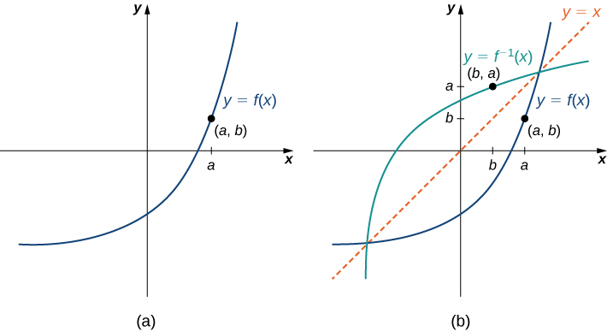

Figure 1.39 (a) The graph of this function shows point on the graph of (b) Since is on the graph of the point is on the graph of The graph of is a reflection of the graph of about the line

|  |
| --- |
| EXAMPLE |
| Example 1.30  |  | | --- | | EXERCISE | | Sketching Graphs of Inverse Functions For the graph of in the following image, sketch a graph of by sketching the line and using symmetry. Identify the domain and range of  An image of a graph. The x axis runs from -2 to 2 and the y axis runs from 0 to 2. The graph is of the function “f(x) = square root of (x +2)”, an increasing curved function. The function starts at the point (-2, 0). The x intercept is at (-2, 0) and the y intercept is at the approximate point (0, 1.4). Solution Reflect the graph about the line The domain of is The range of is By using the preceding strategy for finding inverse functions, we can verify that the inverse function is as shown in the graph.  An image of a graph. The x axis runs from -2 to 2 and the y axis runs from -2 to 2. The graph is of two functions. The first function is “f(x) = square root of (x +2)”, an increasing curved function. The function starts at the point (-2, 0). The x intercept is at (-2, 0) and the y intercept is at the approximate point (0, 1.4). The second function is “f inverse (x) = (x squared) -2”, an increasing curved function that starts at the point (0, -2). The x intercept is at the approximate point (1.4, 0) and the y intercept is at the point (0, -2). In addition to the two functions, there is a diagonal dotted line potted with the equation “y =x”, which shows that “f(x)” and “f inverse (x)” are mirror images about the line “y =x”. | |

|  |
| --- |
| NOTE |
| Checkpoint 1.25  |  | | --- | | EXERCISE | | Sketch the graph of and the graph of its inverse using the symmetry property of inverse functions. | |

#### Restricting Domains

As we have seen, does not have an inverse function because it is not one-to-one. However, we can choose a subset of the domain of such that the function is one-to-one. This subset is called a restricted domain. By restricting the domain of we can define a new function such that the domain of is the restricted domain of and for all in the domain of Then we can define an inverse function for on that domain. For example, since is one-to-one on the interval we can define a new function such that the domain of is and for all in its domain. Since is a one-to-one function, it has an inverse function, given by the formula On the other hand, the function is also one-to-one on the domain Therefore, we could also define a new function such that the domain of is and for all in the domain of Then is a one-to-one function and must also have an inverse. Its inverse is given by the formula ([Figure 1.40](https://cnx.org/contents/8b89d172-2927-466f-8661-01abc7ccdba4@7.4:21bf0e2b-d95b-4e26-b9b9-fb7179ceaed1@8.html#CNX_Calc_Figure_01_04_012)).

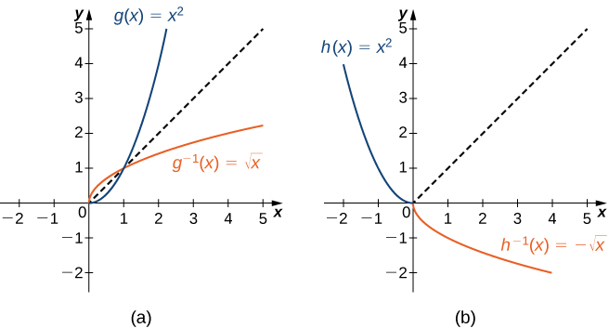

Figure 1.40 (a) For restricted to (b) For restricted to

|  |
| --- |
| EXAMPLE |
| Example 1.31  |  | | --- | | EXERCISE | | Restricting the Domain Consider the function   1. Sketch the graph of and use the horizontal line test to show that is not one-to-one. 2. Show that is one-to-one on the restricted domain Determine the domain and range for the inverse of on this restricted domain and find a formula for  Solution  1. The graph of is the graph of shifted left 1 unit. Since there exists a horizontal line intersecting the graph more than once, is not one-to-one.   An image of a graph. The x axis runs from -6 to 6 and the y axis runs from -2 to 10. The graph is of the function “f(x) = (x+ 1) squared”, which is a parabola. The function decreases until the point (-1, 0), where it begins it increases. The x intercept is at the point (-1, 0) and the y intercept is at the point (0, 1). There is also a horizontal dotted line plotted on the graph, which crosses through the function at two points. 2. On the interval is one-to-one.   An image of a graph. The x axis runs from -6 to 6 and the y axis runs from -2 to 10. The graph is of the function “f(x) = (x+ 1) squared”, on the interval [1, infinity). The function starts from the point (-1, 0) and increases. The x intercept is at the point (-1, 0) and the y intercept is at the point (0, 1).   The domain and range of are given by the range and domain of respectively. Therefore, the domain of is and the range of is To find a formula for solve the equation for If then Since we are restricting the domain to the interval where we need Therefore, Interchanging and we write and conclude that | |

|  |
| --- |
| NOTE |
| Checkpoint 1.26  |  | | --- | | EXERCISE | | Consider restricted to the domain Verify that is one-to-one on this domain. Determine the domain and range of the inverse of and find a formula for | |

### Inverse Trigonometric Functions

The six basic trigonometric functions are periodic, and therefore they are not one-to-one. However, if we restrict the domain of a trigonometric function to an interval where it is one-to-one, we can define its inverse. Consider the sine function ([Figure 1.34](https://cnx.org/contents/6e565dfe-80df-4361-96f3-4eb5aa11e52d#CNX_Calc_Figure_01_03_009)). The sine function is one-to-one on an infinite number of intervals, but the standard convention is to restrict the domain to the interval By doing so, we define the inverse sine function on the domain such that for any in the interval the inverse sine function tells us which angle in the interval satisfies Similarly, we can restrict the domains of the other trigonometric functions to define inverse trigonometric functions, which are functions that tell us which angle in a certain interval has a specified trigonometric value.

|  |
| --- |
| NOTE |
| Definition The inverse sine function, denoted or arcsin, and the inverse cosine function, denoted or arccos, are defined on the domain as follows:  1.12  The inverse tangent function, denoted or arctan, and inverse cotangent function, denoted or arccot, are defined on the domain as follows:  1.13  The inverse cosecant function, denoted or arccsc, and inverse secant function, denoted or arcsec, are defined on the domain as follows:  1.14 |

To graph the inverse trigonometric functions, we use the graphs of the trigonometric functions restricted to the domains defined earlier and reflect the graphs about the line ([Figure 1.41](https://cnx.org/contents/8b89d172-2927-466f-8661-01abc7ccdba4@7.4:21bf0e2b-d95b-4e26-b9b9-fb7179ceaed1@8.html#CNX_Calc_Figure_01_04_015)).

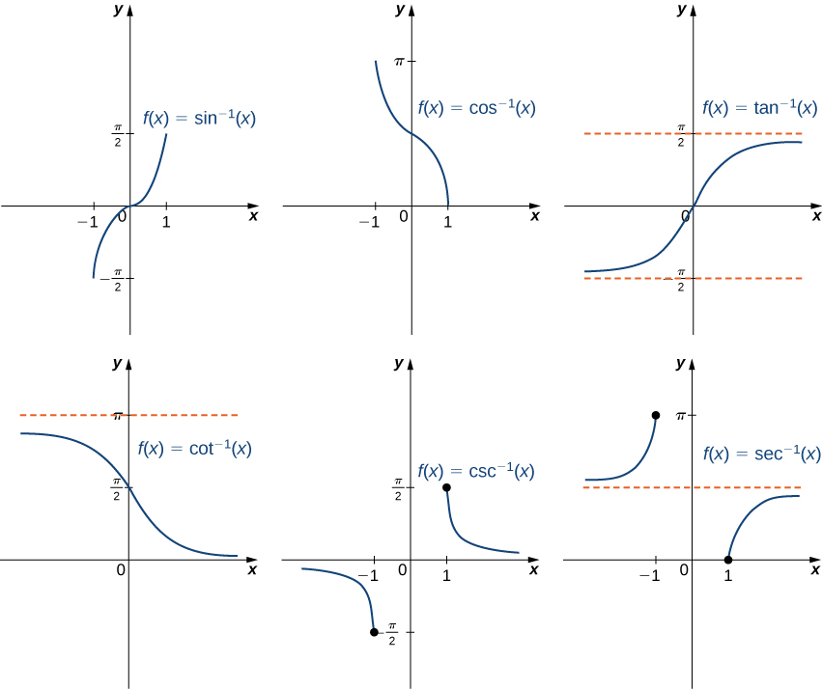

Figure 1.41 The graph of each of the inverse trigonometric functions is a reflection about the line of the corresponding restricted trigonometric function.

|  |
| --- |
| NOTE |
| Media Go to the [following site](http://www.openstax.org/l/20_inversefun) for more comparisons of functions and their inverses. |

When evaluating an inverse trigonometric function, the output is an angle. For example, to evaluate we need to find an angle such that Clearly, many angles have this property. However, given the definition of we need the angle that not only solves this equation, but also lies in the interval We conclude that

We now consider a composition of a trigonometric function and its inverse. For example, consider the two expressions and For the first one, we simplify as follows:

For the second one, we have

The inverse function is supposed to “undo” the original function, so why isn’t Recalling our definition of inverse functions, a function and its inverse satisfy the conditions for all in the domain of and for all in the domain of so what happened here? The issue is that the inverse sine function, is the inverse of the *restricted* sine function defined on the domain Therefore, for in the interval it is true that However, for values of outside this interval, the equation does not hold, even though is defined for all real numbers

What about Does that have a similar issue? The answer is *no*. Since the domain of is the interval we conclude that if and the expression is not defined for other values of To summarize,

and

Similarly, for the cosine function,

and

Similar properties hold for the other trigonometric functions and their inverses.

|  |
| --- |
| EXAMPLE |
| Example 1.32  |  | | --- | | EXERCISE | | Evaluating Expressions Involving Inverse Trigonometric Functions Evaluate each of the following expressions. Solution  1. Evaluating is equivalent to finding the angle such that and The angle satisfies these two conditions. Therefore, 2. First we use the fact that Then Therefore, 3. To evaluate first use the fact that Then we need to find the angle such that and Since satisfies both these conditions, we have 4. Since we need to evaluate That is, we need to find the angle such that and Since satisfies both these conditions, we can conclude that | |

|  |
| --- |
| NOTE |
| Student ProjectThe Maximum Value of a Function In many areas of science, engineering, and mathematics, it is useful to know the maximum value a function can obtain, even if we don’t know its exact value at a given instant. For instance, if we have a function describing the strength of a roof beam, we would want to know the maximum weight the beam can support without breaking. If we have a function that describes the speed of a train, we would want to know its maximum speed before it jumps off the rails. Safe design often depends on knowing maximum values.  This project describes a simple example of a function with a maximum value that depends on two equation coefficients. We will see that maximum values can depend on several factors other than the independent variable *x*.   1. Consider the graph in [Figure 1.42](https://cnx.org/contents/8b89d172-2927-466f-8661-01abc7ccdba4@7.4:21bf0e2b-d95b-4e26-b9b9-fb7179ceaed1@8.html#CNX_Calc_Figure_01_04_016) of the function Describe its overall shape. Is it periodic? How do you know?  * Figure 1.42 The graph of * Using a graphing calculator or other graphing device, estimate the - and -values of the maximum point for the graph (the first such point where *x* > 0). It may be helpful to express the -value as a multiple of π.  1. Now consider other graphs of the form for various values of *A* and *B*. Sketch the graph when *A* = 2 and *B* = 1, and find the - and *y*-values for the maximum point. (Remember to express the *x*-value as a multiple of π, if possible.) Has it moved? 2. Repeat for *A* = 1, *B* = 2. Is there any relationship to what you found in part (2)? 3. Complete the following table, adding a few choices of your own for *A* and *B*:  * *A*  1. Try to figure out the formula for the *y*-values. 2. The formula for the -values is a little harder. The most helpful points from the table are (*Hint*: Consider inverse trigonometric functions.) 3. If you found formulas for parts (5) and (6), show that they work together. That is, substitute the -value formula you found into and simplify it to arrive at the -value formula you found. |

### Section 1.4 Exercises

For the following exercises, use the horizontal line test to determine whether each of the given graphs is one-to-one.

|  |
| --- |
| EXERCISE |
| [183](https://cnx.org/contents/cfd44847-1421-5845-9f39-6dfb7e31d9f1#fs-id1170572547969-solution).  An image of a graph. The x axis runs from -4 to 4 and the y axis runs from -4 to 4. The graph is of a function that decreases in a straight in until the origin, where it begins to increase in a straight line. The x intercept and y intercept are both at the origin. |

|  |
| --- |
| EXERCISE |
| 184.  An image of a graph. The x axis runs from 0 to 7 and the y axis runs from -4 to 4. The graph is of a function that is always increasing. There is an approximate x intercept at the point (1, 0) and no y intercept shown. |

|  |
| --- |
| EXERCISE |
| [185](https://cnx.org/contents/cfd44847-1421-5845-9f39-6dfb7e31d9f1#fs-id1170572548022-solution).  An image of a graph. The x axis runs from -4 to 4 and the y axis runs from -4 to 4. The graph is of a function that resembles a semi-circle, the top half of a circle. The function starts at the point (-3, 0) and increases until the point (0, 3), where it begins decreasing until it ends at the point (3, 0). The x intercepts are at (-3, 0) and (3, 0). The y intercept is at (0, 3). |

|  |
| --- |
| EXERCISE |
| 186.  An image of a graph. The x axis runs from -4 to 4 and the y axis runs from -4 to 4. The graph is of a curved function. The function increases until it hits the origin, then decreases until it hits the point (2, -4), where it begins to increase again. There are x intercepts at the origin and the point (3, 0). The y intercept is at the origin. |

|  |
| --- |
| EXERCISE |
| [187](https://cnx.org/contents/cfd44847-1421-5845-9f39-6dfb7e31d9f1#fs-id1170572548077-solution).  An image of a graph. The x axis runs from -4 to 4 and the y axis runs from -4 to 4. The graph is of a curved function that is always increasing. The x intercept and y intercept are both at the origin. |

|  |
| --- |
| EXERCISE |
| 188.  An image of a graph. The x axis runs from -4 to 7 and the y axis runs from -4 to 4. The graph is of a function that increases in a straight line until the approximate point (, 3). After this point, the function becomes a horizontal straight line. The x intercept and y intercept are both at the origin. |

For the following exercises, a. find the inverse function, and b. find the domain and range of the inverse function.

|  |
| --- |
| EXERCISE |
| [189](https://cnx.org/contents/cfd44847-1421-5845-9f39-6dfb7e31d9f1#fs-id1170572452128-solution). |

|  |
| --- |
| EXERCISE |
| 190. |

|  |
| --- |
| EXERCISE |
| [191](https://cnx.org/contents/cfd44847-1421-5845-9f39-6dfb7e31d9f1#fs-id1170572176863-solution). |

|  |
| --- |
| EXERCISE |
| 192. |

|  |
| --- |
| EXERCISE |
| [193](https://cnx.org/contents/cfd44847-1421-5845-9f39-6dfb7e31d9f1#fs-id1170572549738-solution). |

|  |
| --- |
| EXERCISE |
| 194. |

For the following exercises, use the graph of to sketch the graph of its inverse function.

|  |
| --- |
| EXERCISE |
| [195](https://cnx.org/contents/cfd44847-1421-5845-9f39-6dfb7e31d9f1#fs-id1170572451526-solution).  An image of a graph. The x axis runs from -4 to 4 and the y axis runs from -4 to 4. The graph is of an increasing straight line function labeled “f” that is always increasing. The x intercept is at (-2, 0) and y intercept are both at (0, 1). |

|  |
| --- |
| EXERCISE |
| 196.  An image of a graph. The x axis runs from -4 to 4 and the y axis runs from -4 to 4. The graph is of a curved decreasing function labeled “f”. As the function decreases, it gets approaches the x axis but never touches it. The function does not have an x intercept and the y intercept is (0, 1). |

|  |
| --- |
| EXERCISE |
| [197](https://cnx.org/contents/cfd44847-1421-5845-9f39-6dfb7e31d9f1#fs-id1170572452480-solution).  An image of a graph. The x axis runs from -8 to 8 and the y axis runs from -8 to 8. The graph is of an increasing straight line function labeled “f”. The function starts at the point (0, 1) and increases in straight line until the point (4, 6). After this point, the function continues to increase, but at a slower rate than before, as it approaches the point (8, 8). The function does not have an x intercept and the y intercept is (0, 1). |

|  |
| --- |
| EXERCISE |
| 198.  An image of a graph. The x axis runs from -4 to 4 and the y axis runs from -4 to 4. The graph is of a decreasing curved function labeled “f”, which ends at the origin, which is both the x intercept and y intercept. Another point on the function is (-4, 2). |

For the following exercises, use composition to determine which pairs of functions are inverses.

|  |
| --- |
| EXERCISE |
| [199](https://cnx.org/contents/cfd44847-1421-5845-9f39-6dfb7e31d9f1#fs-id1170572452575-solution). |

|  |
| --- |
| EXERCISE |
| 200. |

|  |
| --- |
| EXERCISE |
| [201](https://cnx.org/contents/cfd44847-1421-5845-9f39-6dfb7e31d9f1#fs-id1170572449207-solution). |

|  |
| --- |
| EXERCISE |
| 202. |

|  |
| --- |
| EXERCISE |
| [203](https://cnx.org/contents/cfd44847-1421-5845-9f39-6dfb7e31d9f1#fs-id1170572548356-solution). |

|  |
| --- |
| EXERCISE |
| 204. |

|  |
| --- |
| EXERCISE |
| [205](https://cnx.org/contents/cfd44847-1421-5845-9f39-6dfb7e31d9f1#fs-id1170572548511-solution). |

|  |
| --- |
| EXERCISE |
| 206. |

For the following exercises, evaluate the functions. Give the exact value.

|  |
| --- |
| EXERCISE |
| [207](https://cnx.org/contents/cfd44847-1421-5845-9f39-6dfb7e31d9f1#fs-id1170572451288-solution). |

|  |
| --- |
| EXERCISE |
| 208. |

|  |
| --- |
| EXERCISE |
| [209](https://cnx.org/contents/cfd44847-1421-5845-9f39-6dfb7e31d9f1#fs-id1170572451384-solution). |

|  |
| --- |
| EXERCISE |
| 210. |

|  |
| --- |
| EXERCISE |
| [211](https://cnx.org/contents/cfd44847-1421-5845-9f39-6dfb7e31d9f1#fs-id1170572142146-solution). |

|  |
| --- |
| EXERCISE |
| 212. |

|  |
| --- |
| EXERCISE |
| [213](https://cnx.org/contents/cfd44847-1421-5845-9f39-6dfb7e31d9f1#fs-id1170572142240-solution). |

|  |
| --- |
| EXERCISE |
| 214. |

|  |
| --- |
| EXERCISE |
| [215](https://cnx.org/contents/cfd44847-1421-5845-9f39-6dfb7e31d9f1#fs-id1170572549009-solution). |

|  |
| --- |
| EXERCISE |
| 216.  The function converts degrees Fahrenheit to degrees Celsius.   1. Find the inverse function 2. What is the inverse function used for? |

|  |
| --- |
| EXERCISE |
| [217](https://cnx.org/contents/cfd44847-1421-5845-9f39-6dfb7e31d9f1#fs-id1170572451744-solution).  **[T]** The velocity *V* (in centimeters per second) of blood in an artery at a distance *x* cm from the center of the artery can be modeled by the function for   1. Find 2. Interpret what the inverse function is used for. 3. Find the distance from the center of an artery with a velocity of 15 cm/sec, 10 cm/sec, and 5 cm/sec. |

|  |
| --- |
| EXERCISE |
| 218.  A function that converts dress sizes in the United States to those in Europe is given by   1. Find the European dress sizes that correspond to sizes 6, 8, 10, and 12 in the United States. 2. Find the function that converts European dress sizes to U.S. dress sizes. 3. Use part b. to find the dress sizes in the United States that correspond to 46, 52, 62, and 70. |

|  |
| --- |
| EXERCISE |
| [219](https://cnx.org/contents/cfd44847-1421-5845-9f39-6dfb7e31d9f1#fs-id1170572547878-solution).  **[T]** The cost to remove a toxin from a lake is modeled by the function  where is the cost (in thousands of dollars) and is the amount of toxin in a small lake (measured in parts per billion [ppb]). This model is valid only when the amount of toxin is less than 85 ppb.   1. Find the cost to remove 25 ppb, 40 ppb, and 50 ppb of the toxin from the lake. 2. Find the inverse function. c. Use part b. to determine how much of the toxin is removed for $50,000. |

|  |
| --- |
| EXERCISE |
| 220.  **[T]** A race car is accelerating at a velocity given by  where *v* is the velocity (in feet per second) at time *t*.   1. Find the velocity of the car at 10 sec. 2. Find the inverse function. 3. Use part b. to determine how long it takes for the car to reach a speed of 150 ft/sec. |

|  |
| --- |
| EXERCISE |
| [221](https://cnx.org/contents/cfd44847-1421-5845-9f39-6dfb7e31d9f1#fs-id1170572543027-solution).  **[T]** An airplane’s Mach number *M* is the ratio of its speed to the speed of sound. When a plane is flying at a constant altitude, then its Mach angle is given by  Find the Mach angle (to the nearest degree) for the following Mach numbers.  An image of a birds eye view of an airplane. Directly in front of the airplane is a sideways “V” shape, with the airplane flying directly into the opening of the “V” shape. The “V” shape is labeled “mach wave”. There are two arrows with labels. The first arrow points from the nose of the airplane to the corner of the “V” shape. This arrow has the label “velocity = v”. The second arrow points diagonally from the nose of the airplane to the edge of the upper portion of the “V” shape. This arrow has the label “speed of sound = a”. Between these two arrows is an angle labeled “Mach angle”. There is also text in the image that reads “mach = M > 1.0”. |

|  |
| --- |
| EXERCISE |
| 222.  **[T]** Using find the Mach number *M* for the following angles. |

|  |
| --- |
| EXERCISE |
| [223](https://cnx.org/contents/cfd44847-1421-5845-9f39-6dfb7e31d9f1#fs-id1170572551494-solution).  **[T]** The temperature (in degrees Celsius) of a city in the northern United States can be modeled by the function  where is time in months and corresponds to January 1. Determine the month and day when the temperature is |

|  |
| --- |
| EXERCISE |
| 224.  **[T]** The depth (in feet) of water at a dock changes with the rise and fall of tides. It is modeled by the function  where is the number of hours after midnight. Determine the first time after midnight when the depth is 11.75 ft. |

|  |
| --- |
| EXERCISE |
| [225](https://cnx.org/contents/cfd44847-1421-5845-9f39-6dfb7e31d9f1#fs-id1170572545202-solution).  **[T]** An object moving in simple harmonic motion is modeled by the function  where is measured in inches and is measured in seconds. Determine the first time when the distance moved is 4.5 in. |

|  |
| --- |
| EXERCISE |
| 226.  **[T]** A local art gallery has a portrait 3 ft in height that is hung 2.5 ft above the eye level of an average person. The viewing angle can be modeled by the function  where is the distance (in feet) from the portrait. Find the viewing angle when a person is 4 ft from the portrait. |

|  |
| --- |
| EXERCISE |
| [227](https://cnx.org/contents/cfd44847-1421-5845-9f39-6dfb7e31d9f1#fs-id1170572169169-solution).  **[T]** Use a calculator to evaluate and Explain the results of each. |

|  |
| --- |
| EXERCISE |
| 228.  **[T]** Use a calculator to evaluate and Explain the results of each. |